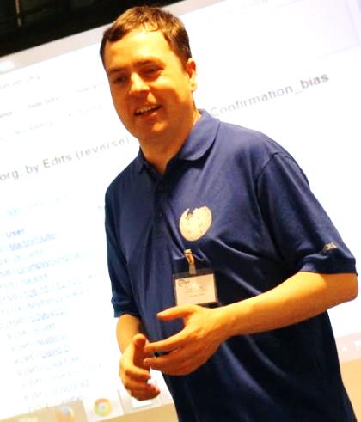
Wikimedian In Residence at the Bodleian Libraries

Dr Martin Poulter is on a one-year placement, helping academics, students, librarians and the public to open up knowledge to the world on Wikipedia.
The events he offers include:
Edit-a-thons: experts, experienced Wikipedians, and anyone else with an interest work together to improve articles on a topic, with basic training for those new to wiki editing
All are welcome to a series of edit-a-thons in October on the theme of Women in Science

Workshops for researchers on using Wikipedia to maximize impact and feed public curiosity about their field

Workshops for educators on running assignments where students improve Wikipedia articles

Workshops for library and museum staff on using Wikimedia platforms to share digital media and texts and to promote public engagement

Email: martin.poulter@bodleian.ox.ac.uk for more
Photograph above by Simon Thomson, CC-BY. Over: Arthrobacter arilaitensis Re117 genome atlas by Monnet C, Loux V, Gibrat J-F, Spinnler E, Barbe V, et al. via PLOS ONE, CC-BY.

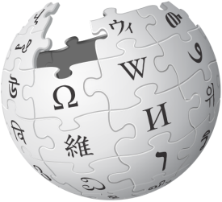
Did you know?
Wikipedia and science
Wikipedia is one of the top ten most visited websites. Its many language versions reach around half a billion people per month.
It is also, according to CrossRef, a top ten site sending readers to scholarly papers. Open access papers are 46% more likely to be cited.
All contributors are volunteers. Many already qualified in the relevant fields, or are studying for higher degrees.
Wikipedia has ten sister projects. They include Wikidata (for facts and figures), Wikibooks (textbooks) and Commons (images and media).
The articles, images and other content of Wikimedia projects are free to reuse by anyone, for any purpose.
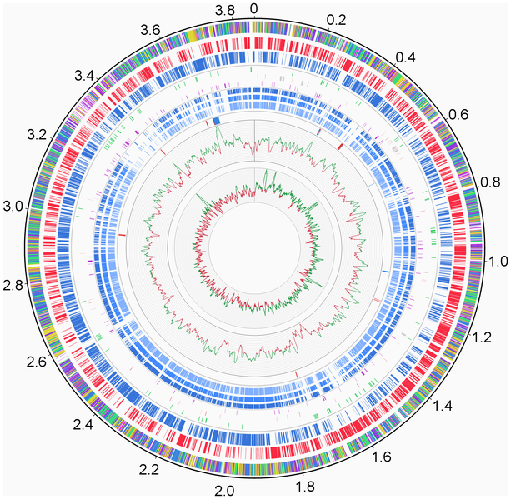
The Royal Society, Cancer Research UK, the Royal Society of Chemistry and the Wellcome Library are among the institutions that have worked formally with Wikimedia to share scientific knowledge.

’If you're serious about ensuring public engagement in your research then you need to make damn sure your work can be incorporated into Wikipedia. Wikipedia is the most important engagement channel for your research.’ – Cameron Neylon, Public Library of Science
‘Wikidata is the future of science data.’
– Peter Murray-Rust, University of Cambridge

